Thesis/Paper Title

Your Name:
Name of Supervisor:
Hand in Date:
Version:

Table of Contents
I. Level 1 1
I.1. Level 2 1
I.1.1. Level 3 1
I.1.2. Level 3 1
I.1.2.a. Level 4 1
I.1.2.b. Level 4 1
I.2. Level 2 1
I.2.1. Level 3 1
I.2.1.a. Level 4 1
I.2.2. Level 3 1
II. Level 1 1
II.1. Level 2 1
II.1.1. Level 3 2
II.1.2. Level 3 2
II.1.3. Level 3 4
II.1.3.a. Level 4 4
III. Level 1 4
ANNEX 5

General Information
This template is specifically for students who want/need to write their thesis or a longer paper which needs a table of content, different styles and page numbers. Focus of this template lies on simplicity and ease of usage. If you need a more sophisticated template check out the ones below:
- Dissertation template by Matthias Ansorg
- Dissertation template & Tutorial (in German) by Humboldt University (Sabine Henneberger & Matthias Schulz)
Additional Information
If you have some useful information (other templates, links, tutorials etc.) relevant for students who want to write a longer paper or thesis, drop us a line at coreteam@vodes.net and we include it here.
- OpenOffice Guide (> 400 pages) on available on how to use OpenOffice-writer
- General Tips (German) how to write/format a thesis with OpenOffice/StarOffice by Werner Roth
VN Video Tutorials
There are three VN video tutorials available. Most relevant in context of this template, the tutorial Customising Thesis Template shows how to use and adjust this template to your individual needs.
- Customising Thesis Template
- Paragraph Styles
- Page Styles and Page Numbers

You are advised to get a high quality version on P2P networks (e.g. Bittorrent):
torrent (on www.mininova.org)
Feature Requests and Questions
If you want to have a feature included in the next version of this template or have a question, feel free to drop us a line at coreteam@vodes.net.
How to...
...Add New Chapters and Sections (“Levels”)
Simply copy the “Level” you want to add and paste it where you want to have it. The numbering of the levels/sections is updated automatically. You need to update your table of content by (a) moving the cursor in the table of content,(b) right clicking and (c) selecting Update Index/Table).
...Change Styles (colour, font size etc)
Use paragraph styles to change colour, font size, etc. This template uses Heading/title/contents 1, 2, 3 and 4 and Text body as paragraph styles. Watch the paragraph styles tutorial for more.
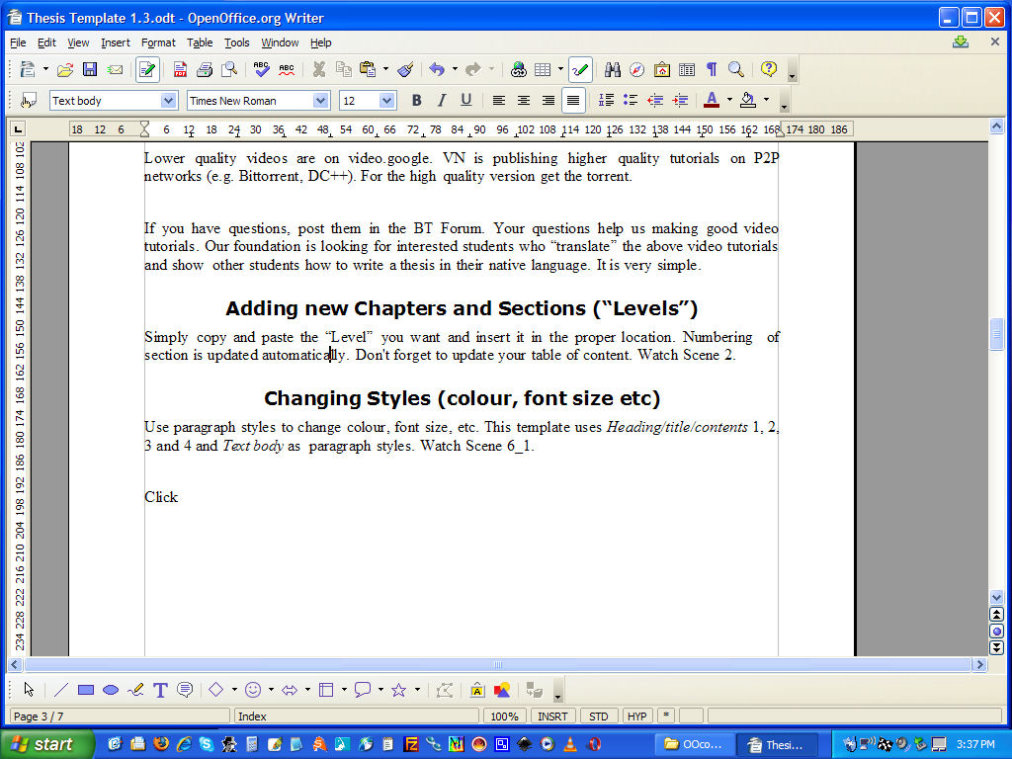
3 Steps:

- Click the styles icon:

- Move cursor over the text you want to change
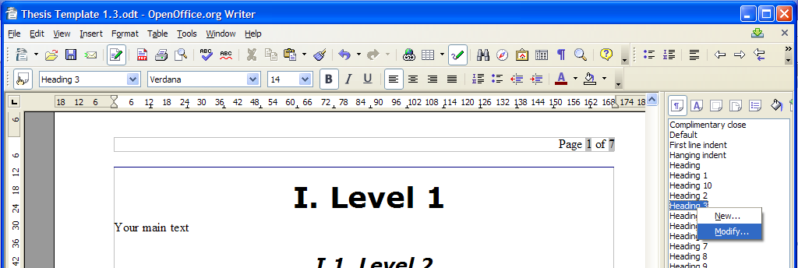
- Right click the highlighted style in the paragraph styles menu on the right (Heading 3 in the example below) and modify/adjust to your individual needs

...Export to .pdf
If you want to export your thesis into a .pdf file, simply click the .pdf icon as shown on the right.

Level 1
Your main text

Level 2
Your main text

Level 3
Your main text

Level 3
Your main text

Level 4
Your main text

Level 4
Your main text

Level 2
Your main text

Level 3
Your main text

Level 4

Level 3

Level 1
Your main text

Level 2
Your main text

Level 3
Your main text

Level 3
Your main text

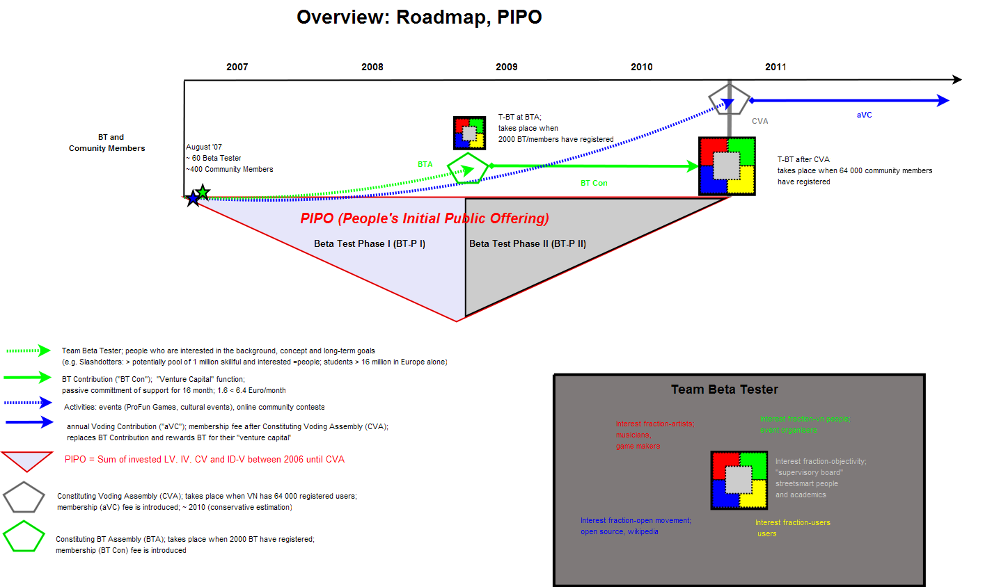
Graph x

Level 3
Your main text

Level 4

Level 1

ANNEX

